Strengths
1. Government Support & Policy Alignment:
- The EU is actively supporting the transition to renewable energy through policy frameworks and financial incentives (such as the Green Deal, REPowerEU).
- Renewable energy projects are highly favored by regulations aimed at reducing carbon emissions and achieving net-zero targets.

2. Technological Advancements:
- Continued technological improvements in solar, wind, and battery storage make renewable energy more efficient and cost-effective.
- Digital transformation is enabling better grid management, integration of renewables, and smart energy systems (e.g., AI and IoT in energy management).

3. Sustainability and Public Demand:
- Renewable energy contributes significantly to sustainability goals, aligning with global and EU environmental policies.
- Growing public awareness and consumer demand for cleaner, greener energy solutions.
4. Job Creation and Economic Development:
- The renewable energy sector is generating new jobs in manufacturing, maintenance, and research.
- It fosters economic growth in regions transitioning from fossil fuels to renewables.

Weaknesses
1. High Initial Investment Costs:
- Renewable energy technologies, especially solar panels, offshore wind farms, and energy storage solutions, often require significant upfront investment.

2. Intermittency and Reliability Issues:
- Some renewable energy sources, such as wind and solar, are intermittent and weather-dependent, posing challenges for continuous power supply.
- Energy storage solutions are still in development and may not yet fully compensate for supply gaps.
3. Infrastructure and Grid Compatibility:
- Existing energy grids are often not designed for renewable integration, requiring significant investment in upgrading and adapting the infrastructure.
- Smart grids and energy storage technologies are still developing, and their widespread deployment faces technical and financial barriers.
4. Regulatory and Policy Uncertainty:
- Changes in government policies or subsidies can create market instability.
- Inconsistent regulations across countries or regions could slow the adoption of renewable energy solutions.

Opportunities
1. EU Transition Pathways and Funding:
- EU funding mechanisms, such as the Horizon 2020 program, the Green Deal, and REPowerEU, provide financial support for the transition to renewable energy.
- As the EU works towards carbon neutrality, opportunities for renewable energy projects increase.

2. Global Market Growth:
- The global transition to renewable energy opens up new markets for EU companies, particularly in emerging economies looking to diversify energy sources.
3. Innovation in Energy Storage and Smart Grids:
- Advancements in battery technology and energy storage solutions will enhance the reliability and scalability of renewable energy.
- The development of smart grids and decentralized energy systems offers more flexibility in managing renewable energy sources and consumer needs.
4. Cross-Sector Integration:
- Renewable energy has the opportunity to integrate with other sectors like transportation (electric vehicles), construction (energy-efficient buildings), and agriculture (bioenergy), contributing to holistic sustainability.

5. Carbon Credit Market:
- The EU Emissions Trading System (ETS) and carbon credit markets are expanding. Renewable energy companies can tap into these markets to sell carbon credits, adding financial incentives to projects.

Threats
1. Competition from Other Energy Sources:
- Fossil fuels and nuclear energy may remain competitive in regions where renewable energy infrastructure is not well developed or where subsidies favor non-renewable sources.
- The rise of "greenwashing" could lead to skepticism about renewable energy investments.
2. Geopolitical Risks:
- Global supply chains for renewable technologies (e.g., rare earth metals for batteries and solar panels) are vulnerable to geopolitical tensions.
- Trade barriers, tariffs, or import/export restrictions could disrupt the renewable energy market.
3. Environmental and Social Opposition:
- Renewable energy projects can face opposition from local communities, especially for large-scale projects like wind farms and solar power plants.
- Environmental concerns, such as the impact of wind farms on bird populations or the land use required for solar panels, may result in regulatory delays or public opposition.

4. Technology Development Delays:
- While technology is progressing, breakthroughs in energy storage and grid compatibility are still required to make renewable energy more reliable.
- Potential delays in developing next-generation renewable energy technologies could hinder progress towards climate goals.

Summary of Renewable Energy Strengths, Weaknesses, Opportunities, and Threats (SWOT) Analysis
Strengths:
- Government Support & Policy Alignment: The EU provides strong policy backing and financial incentives (e.g., Green Deal, REPowerEU) to promote renewable energy.
- Technological Advancements: Innovations in solar, wind, and battery storage enhance efficiency and cost-effectiveness; digital transformation enables smart energy systems.
- Sustainability & Public Demand: Growing environmental awareness drives demand for green energy, aligning with global sustainability goals.
- Job Creation & Economic Growth: The renewable sector generates employment in manufacturing, maintenance, and research, fostering economic expansion.
Weaknesses:
- High Initial Costs: Substantial upfront investment is required for infrastructure, particularly for solar, offshore wind, and storage technologies.
- Intermittency & Reliability Issues: Dependence on weather conditions and limited energy storage pose challenges to continuous supply.
- Infrastructure & Grid Compatibility: Existing grids need upgrades for renewable integration, facing financial and technical barriers.
- Regulatory & Policy Uncertainty: Policy shifts and inconsistent regulations across regions may hinder renewable energy adoption.
Opportunities:
- EU Transition Pathways & Funding: Programs like Horizon 2020 and REPowerEU provide financial support for clean energy projects.
- Global Market Growth: Emerging economies present new markets for EU renewable energy technologies.
- Innovation in Storage & Smart Grids: Advances in battery storage and decentralized grids will improve reliability and scalability.
- Cross-Sector Integration: Opportunities exist to integrate renewables with electric vehicles, sustainable construction, and bioenergy.
- Carbon Credit Market: The EU Emissions Trading System (ETS) allows renewable companies to monetize carbon credits.
Threats:
- Competition from Fossil Fuels & Nuclear Energy: Non-renewables remain competitive due to existing infrastructure and subsidies.
- Geopolitical Risks: Supply chain vulnerabilities for key materials (e.g., rare earth metals) could disrupt progress.
- Environmental & Social Opposition: Large-scale projects face public resistance due to environmental concerns and land use conflicts.
- Technology Development Delays: Delays in advancing energy storage and smart grid solutions may slow the transition to a fully renewable system.

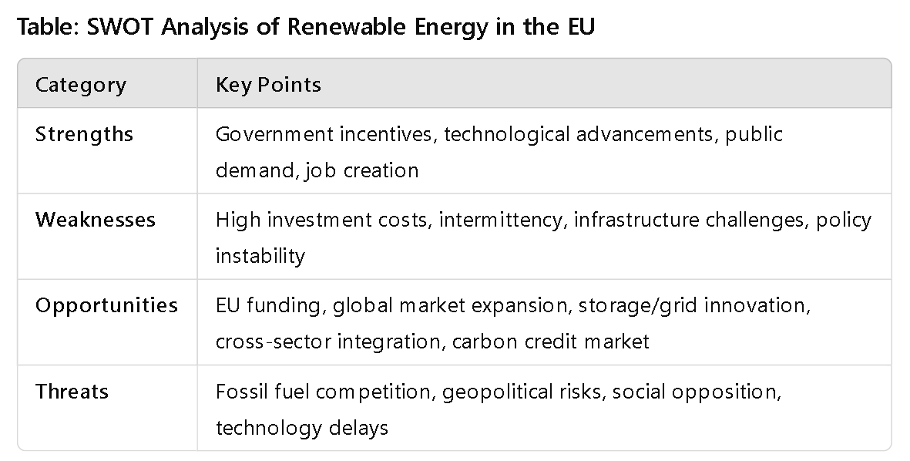

References
1. European Commission. (n.d.). Industry transition pathways. European Commission. Retrieved from https://single-market-economy.ec.europa.eu/industry/transition-pathways_en
2. European Commission. (2020). The European Green Deal. European Commission. Retrieved from https://ec.europa.eu/info/strategy/priorities-2019-2024/european-green-deal_en
3. European Commission. (2022). REPowerEU: Plan to rapidly reduce dependence on Russian fossil fuels and fast forward the green transition. European Commission. Retrieved from https://ec.europa.eu/energy/topics/energy-security/repowereu_en
4. International Energy Agency (IEA). (2021). Renewable energy market update 2021. International Energy Agency. Retrieved from https://www.iea.org/reports/renewable-energy-market-update-2021
5. BloombergNEF. (2021). New energy outlook 2021. Bloomberg New Energy Finance. Retrieved from https://about.bnef.com/new-energy-outlook/

